RSN Sea Snake

*Aipysurus laevis laevis* Lacepede, *A. laevis pooleorum* subsp. nov.,

*A. duboisii* Bavay, *A. apraefrontalis* M.A. Smith, *A. tenuis* Lonnberg and

Andersson, *A. eydouxii* (Gray), *Hydrophis ocellatus* Gray, *H. major* (Shaw),

*H. kingii* Boulenger, *H. elegans* (Gray), *Acalyptophis peronii* (Dum€ril),

*Astrotia stokesii* (Gray), *Hydrelaps darwiniensis* Boulenger, *Ephalophis greyii*

M.A. Smith and *Pelamis platurus* (Linnaeus).

Emydocephalus annulatus (tropical west and east Australia)

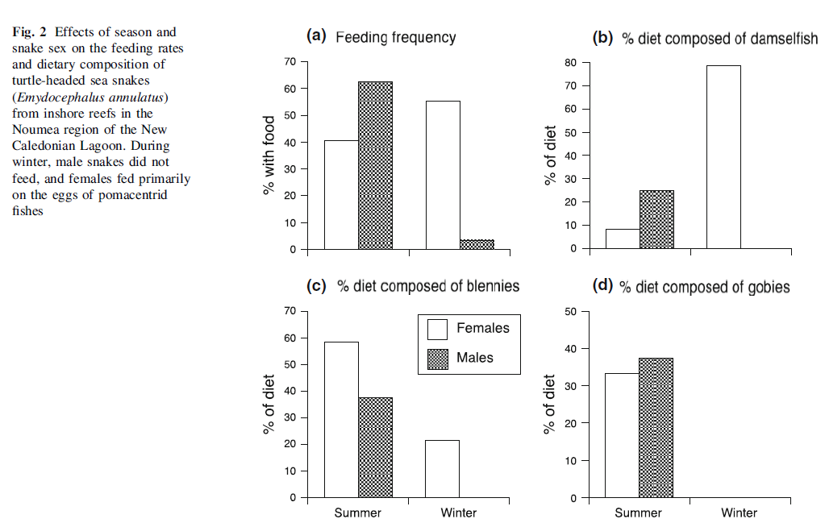

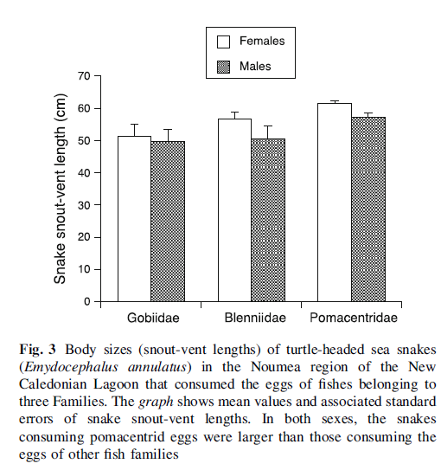

Eel eaters.--*Hydrophis brookii, Hydrophisfasciatus, Hydrophis melanosoma, Laticauda colubrina* and *Microcephalophis gracilis* feed on anguilliform eels of four families,

Burrowing goby eaters.--Hydrophis caerulescens and Acalyptophis peronii feed predominantly on Trypauchenidae.

Goby eaters.-Acrochordus granulatus in the Straits of Malacca feeds on goby-like fishes that all be-long to the suborder Gobioidei.

Egg eaters.-Aipypysurus eydouxii is the only fish-egg eating species in the snake assemblages ex-amined in this study. The demersal eggs found in stomachs of A. eydouxii are similar to those found in the stomachs of Emydocephalus (Voris, 1966) and are assumed to have been taken from the burrows of small bottom dwelling fishes such as the gobies.

Catfish eaters.-A large sample of stomach con-tents indicates that Enhydrina schistosa at Muar feeds mainly on ariid and plotosid catfish. These fish frequently occur in small schools on or near the bottom. Details on the diet and feeding behavior of E. schistosa can be found elsewhere (Voris et al., 1978). No other well-sampled snake species in this study feeds on catfish.

Generalists.-Of the marine snake species rep-resented at the localities studied, only L. hard-wickii is a generalist, feeding on 21 families of fishes and two types of invertebrates, squid and cuttle fish. Its fish prey range from burrowing types such as gobies, burrowing gobies and eels to more pelagic forms such as the parrotfish and squid.

|  |  |
| --- | --- |
| **prey item** | **probability of consuming** |
| FDT | 0.3 |
| CEP | 0.2 |
| FLR | 0.1 |
| FSR | 0.1 |
| FDC | 0.05 |
| FDO | 0.05 |
| FMA | 0.05 |

References

Smith., L.A. 1974. The sea snakes of Western Australia (Serpentes: Elapidae, Hydrophiinae) with a description of a new subspecies. *Rec. West. Aust. Mus.,* 1974, 3 (2)

Arnold SJ (1993) Foraging theory and prey-size-predator-size relations in snakes. In: Seigel RA, Collins JT (eds) Snakes: ecology

and behaviour. McGraw-Hill, New York, pp 87–116

Shine R (1991) Why do larger snakes eat larger prey? Funct Ecol 5:493–502

Glodek GS, Voris HK (1982) Marine snake diets: prey composition, diversity and overlap. Copeia 1982:661–666

Shine R, Bonnet X, Elphick M, Barrott E (2004) A novel foraging mode in snakes: browsing by the sea snake Emydocephalus annulatus (Serpentes, Hydrophiidae). Funct Ecol 18:16–24

Voris HK (1966) Fish eggs as the apparent sole food item for a genus of sea snake, Emydocephalus (Krefft). Ecology 47:152–154

C. Goiran, S. Dubey, R. Shine. 2013. Effects of season, sex and body size on the feeding ecology of turtle-headed sea snakes (Emydocephalus annulatus) on IndoPacific inshore coral reefs. Coral Reefs (2013) 32:527–538